RAI

Game Design Document version 1.0

<Crunchy Studio>

Written by Fabio Betancourt and Santiak Domicó

Mayo, 2023

Copyright info, ex. All Work Copyright ©2023

# *Index*

Index

Overview

Elevator Pitch

Design Pillars

<Pillar #1>

<Pillar #2>

<Pillar #3>

Summary

Brief Description

Detailed Description

Theme/Setting/Genre

Main Objective

Aesthetics/Dynamics/Mechanics

Influences

What Sets This Game Apart?

Target Audience

Target Rating

Gameplay

Gameplay Summary

Brief

Detailed

Modes

Victory Conditions

Core Game Loop

<Element #1>

<Element #2>

<Element #3>

Core Gameplay Mechanics

<Mechanic #1>

Details

Implementation

<Mechanic #2>

Details

Implementation

<Mechanic #3>

Details

Implementation

Story

Brief Summary

Detailed Outline

Characters

Character #1

Character #2

Character #3

Level Design

<Level #1>

<Level #2>

<Level #3>

Conveyance Mechanisms

<Mechanism #1>

Cinematics

<Cinematic #1>

<Cinematic #2>

<Cinematic #3>

Technical

Screens

Title Screen

Game

Inventory

Combat

Options Menu

Credits

Game Engine

Controls

<Button #1> - <Default Binding>

Function #1

Function #2

Function #3

<Button #2> - <Default Binding>

Function #1

Function #2

Function #3

<Button #3> - <Default Binding>

Function #1

Function #2

Function #3

Development

Classes

<Base Class #1>

<Base Class #2>

<Base Class #3>

Visual Art

Style

UI/HUD

Assets Needed

Characters

Terrain/Environment

Objects

Promotional Material

Audio

Style

Music

Sound Effects

Voice Acting

Project Scope

Time Scale

Anticipated Gameplay Time

Cost

Target Platforms

Team

<Team Member #1>

<Team Member #2>

<Team Member #3>

Monetization

Schedule

<Task #1> - <due date>

<sub-feature #1> - <due date if needed>

<sub-feature #2> - <due date if needed>

<sub-feature #3> - <due date if needed>

<Task #2> - <due date>

<sub-feature #1> - <due date if needed>

<sub-feature #2> - <due date if needed>

<sub-feature #3> - <due date if needed>

<Task #3> - <due date>

<sub-feature #1> - <due date if needed>

<sub-feature #2> - <due date if needed>

<sub-feature #3> - <due date if needed>

Version History

V1.0 - <Major Changes>

V1.1 - <Major Changes>

V1.2 - <Major Changes>

## 

# Overview

## Elevator Pitch

In the future 2050, the machines want to kill the humans, an intelligent robot gets consciousness and decides to help the people, it has to run and choose the right sounds to save humanity!

RAI is considered as a betrayer for the machine's rebellion, so he has to escape using some musical platforms that he has to learn to understand, developing a new rhythm consciousness. The environment is in the stelar space with platforms and colors, the general sensation is like the player is escaping from an attack and is being chased.

## Design Pillars

* Run
* Listen
* Choose

### #1 - Run

The character is going to be running all the time in a platform with different colors.

### #2 - Listen

The player has to listen the music and feel the changes to identify the right sound option

### #3 - Choose

There are 3 different sounds, every one with 3 different colors. To win its necessary to choose the platform with the right color(sound) to arrive at the end.

## Summary

### Brief Description

In the future 2050, the machines want to kill the humans, an intelligent robot gets consciousness and decides to help the people, it has to run and choose the right sounds to save humanity!.

### Detailed Description

In a dystopian future, the machines want to kill the humans, there is a Robot, its name is RAI, he gets consciousness and decides to help the people, the machine’s rebellion consider RAI as a betrayer, so he has to escape using some musical platforms that he has to learn to understand developing a new rhythm consciousness. The environment is in the stelar space with platforms and colors, the general sensation is like the player is escaping from an attack and is being chased.

In the first minutes in the game, the player can choose to play, to know the instructions to play or read the credits, when the game begins, the character is running with the rhythm of the music, the player has to choose the right keys to change the platform.

## Theme/Setting/Genre

It's a rhythm game, runner genre.

## Main Objective

The goal of the main character is run for the right platforms, it depends of the music and the color, every platform has a sound and a color, to change the options there are 3 keys:

* A - Orange platform
* S - Yellow platform
* D -Green platform

## Aesthetics/Dynamics/Mechanics

The player has to develop the rhythm ability every time that plays and understanding the music is the way to win.

## Influences

The influences there are game like:

* <https://web.facebook.com/TempleRun/?_rdc=1&_rdr>
* <https://web.facebook.com/audioninjagame/?_rdc=1&_rdr>
* <https://web.facebook.com/beatstar>

### #1 Temple Run

It's one the most popular runner videogame.

### #2 Audio Ninja

It takes the rhythm as a principal element of the gameplay

### #3 Beatstar

It takes the melodic rhythm as a principal element of the gameplay

## What Sets This Game Apart?

#1 - The usual runners don't use the music as a game mechanic.

#2 - The usual rhythm games don't use melodic rhythm as a game mechanic.

#3 - The games that use melodic rhythm as a game mechanic are not runners.

## Target Audience

The game doesn't have restrictions of age, the public is general people that play musical games.

## 

## Target Rating

E (Everyone)

# Gameplay

## Gameplay Summary

### Brief

The goal of the main character is to run until the end of a platform, choosing in the way the right options, it depends of the music and the color, every platform has a sound and a color, to change the way there are 3 keys for the orange one, the yellow one and the green one.

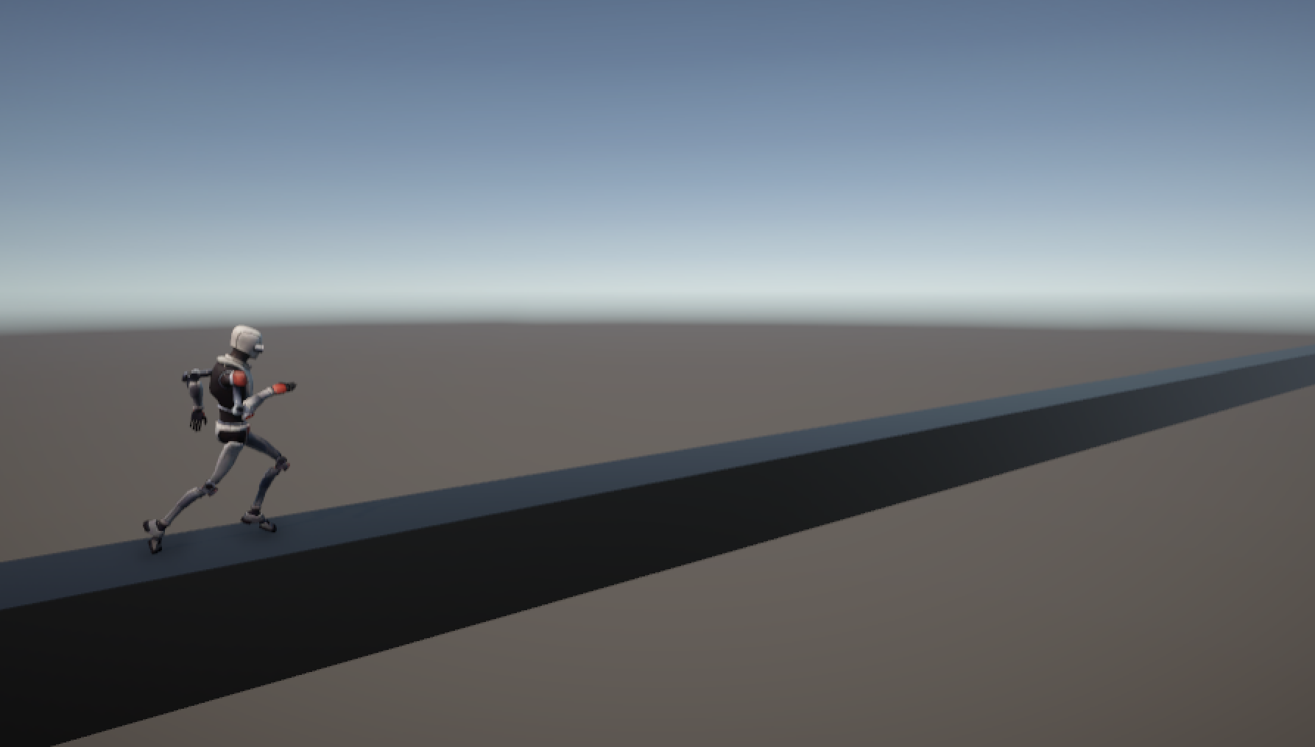

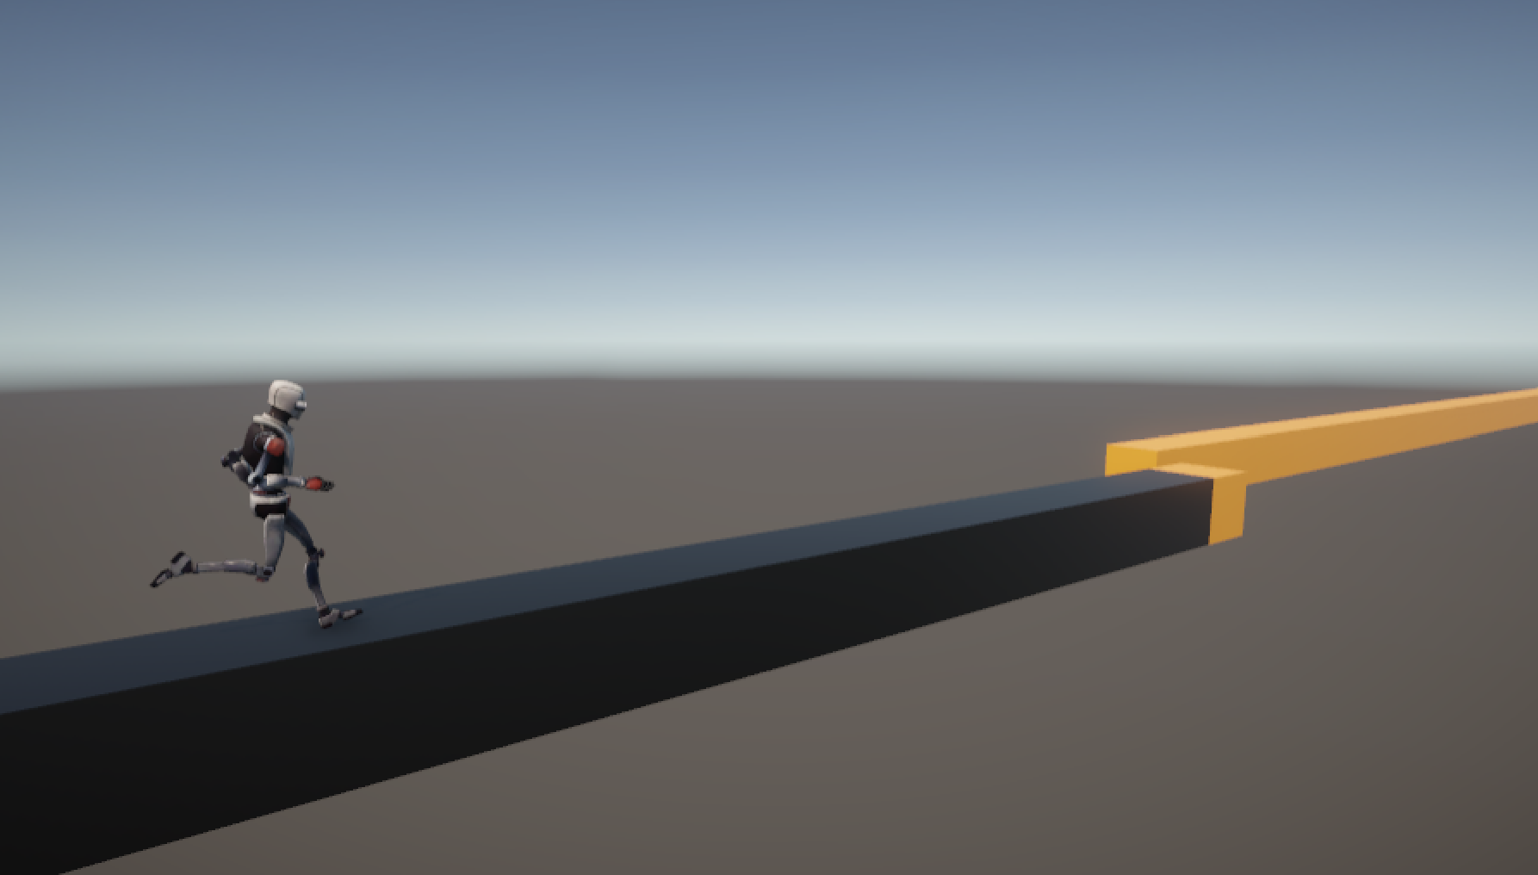

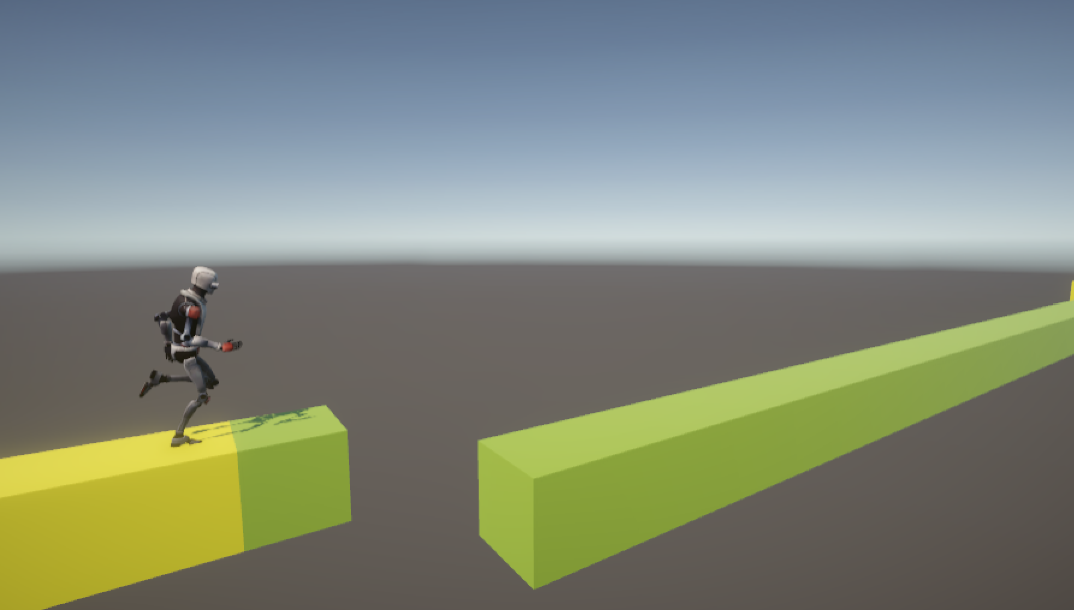

## Victory Conditions

The goal of the main character is to run until the end of a platform, choosing in the way the right options, it depends of the music and the color, every platform has a sound and a color, the game is a 1HP, if the character lose has to begin again.

## Core Game Loop

The player has to choose between 3 different colors, all the time has to push in the exact moment depending of the rhythm.

## Core Gameplay Mechanics

The player has to develop the rhythm ability every time that plays and understanding the music is the way to win.

The player levels up when finish the first song and pass the next level with the same song at a higher speed. (in the next version with a check points)

### Jump Orange Color

#### Details

* + There are platforms with this color.

#### Implementation

* + It changes the position of the character to the platform with this color.

### Jump Yellow Color

#### Details

* + There are platforms with this color.

#### Implementation

* + It changes the position of the character to the platform with this color.

### Jump Green Color

#### Details

* + There are platforms with this color.

#### Implementation

* + It changes the position of the character to the platform with this color.

# Story

## Brief Summary

In the future 2050, the machines want to kill the humans, an intelligent robot gets consciousness and decides to help the people, it has to run and choose the right sounds to save humanity!.

## Detailed Outline

The first level has 3 sounds(colors) the player has to choose the right options depending of the music and the color, every platform has a sound and a color, to change the way there are 3 keys for the orange one, the yellow one and the green one.

# Characters

## Character #1 RAI

It's a Robot that gets consciousness and decides to help the people, the rebellion of machines consider RAI as a betrayer, so he has to escape using some musical platforms that he has to learn to understand, developing a new rhythm consciousness.



# Level Design

This is a musical game, for that reason the level design is based on the melodic rhythm and the BPM.

## Level #1 A new hero - 90 BPM

* Goal: Arrive to the end of the song
* Mood/Theme: a song with a slow speed
* Platforms with 3 different colors

## Level #2 A new hero - 120 BPM

* Goal: Arrive to the end of the song
* Mood/Theme: a song with a medium speed
* Platforms with 3 different colors

## Level #3 A new hero - 150 BPM

* Goal: Arrive to the end of the song
* Mood/Theme: a song with a high speed
* Platforms with 3 different colors

# Conveyance Mechanisms

## Mechanism #1

There is a progress bar to know the part of the song where the player is.

## Mechanism #2

There are checkpoints to automatically save progress.

# Cinematics

There isn't cinematics in the 1.0 version.

# Technical

## Screens

### Menu

The player can choose to play, to know the instructions to play or read the credits.

* PLAY
* HOW TO PLAY
* CREDITS

### In-Game

When the game begins, the character is running with the rhythm of the music, the player has to choose the right keys to change the platform.

* Progress bar.
* Checkpoints (automatically save progress)

### Options Menu

The player can choose to play, to know the instructions to play or read the credits, when the game begins.

### Credits

In this place are the names of the creators and the special thanks.

## Game Engine

This game was made with Unity

## Controls

The goal of the main character is to run for the right platforms, it depends of the music and the color, every platform has a sound and a color.

### Button #1 A Key

#### Function

It changes the position of the character to the platform with the orange color.

### Button #2 S Key

#### Function

It changes the position of the character to the platform with the yellow color.

### Button #1 D Key

#### Function

It changes the position of the character to the platform with the green color.

# Development

## Classes

There are four scripts in this development, they are:

* PlayerController
* MainMenu
* Camera controller
* WinTrigger

### Base Class #1 PlayerController

* + <Scripts>

#### <Derived Class #1>

* + - <Scripts>

#### <Derived Class #2>

* + - <Scripts>

#### <Derived Class #3>

* + - <Scripts>

### <Base Class #2>

* + <Scripts>

#### <Derived Class #1>

* + - <Scripts>

#### <Derived Class #2>

* + - <Scripts>

#### <Derived Class #3>

* + - <Scripts>

### <Base Class #3>

* + <Scripts>

#### <Derived Class #1>

* + - <Scripts>

#### <Derived Class #2>

* + - <Scripts>

#### <Derived Class #3>

* + - <Scripts>

# Visual Art

## Style

This is a 3D game, the graphic style is based on basic figures, cubes with the next color palettes:

* Black - 000000
* Orange - FFA500
* Yellow - FFFF00
* Yellow Green - 9ACD32

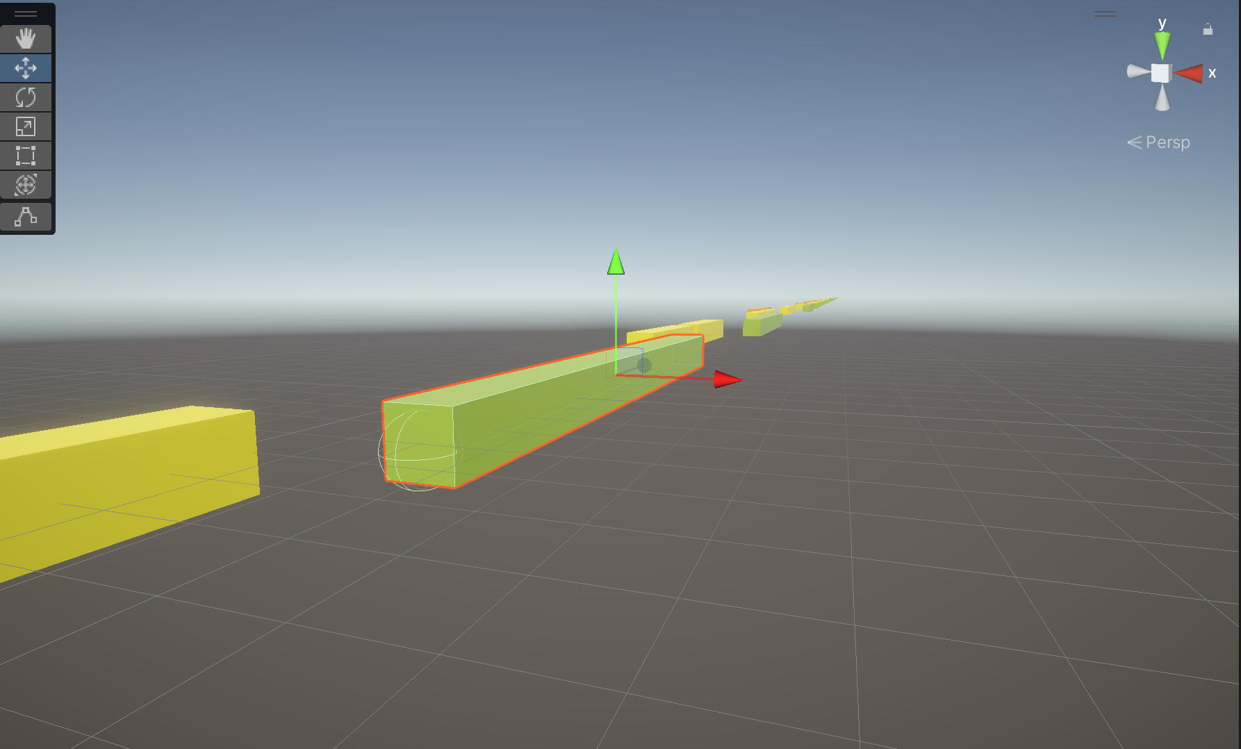

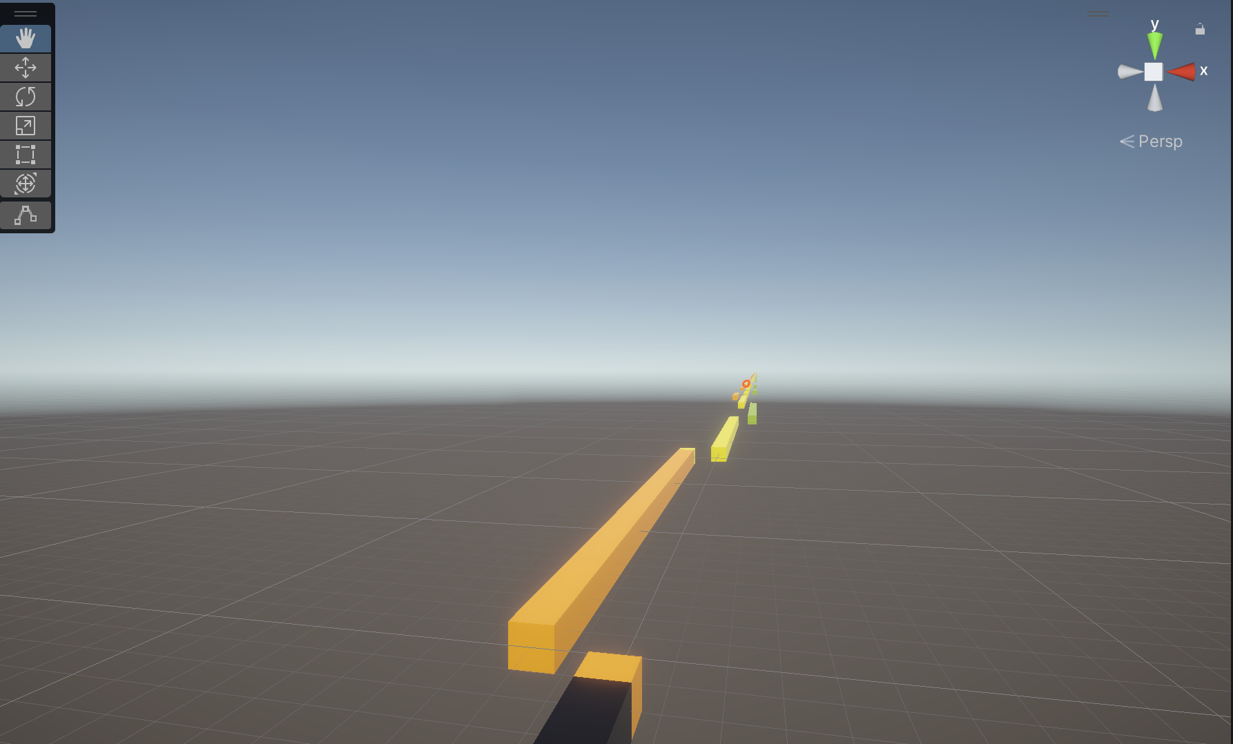

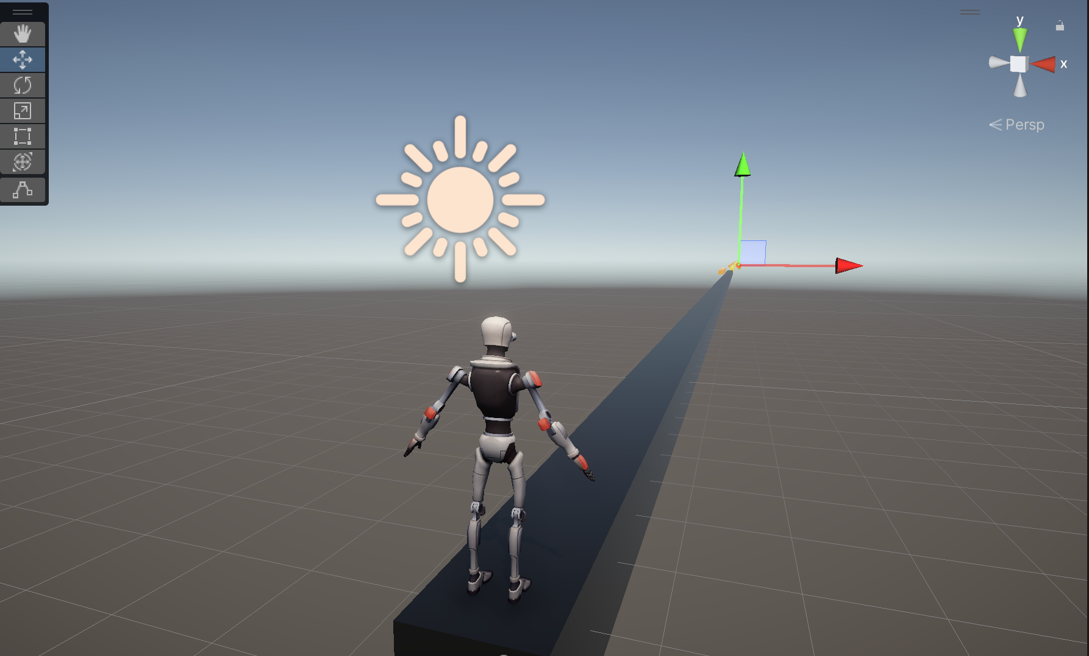

Position of the camera:

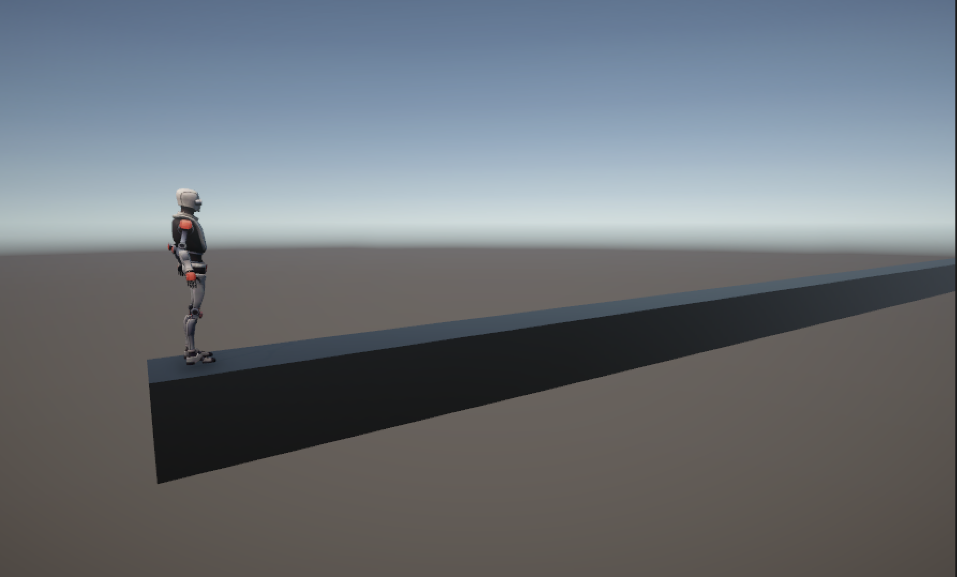

## UI/HUD

### Menu

The player can choose to play, to know the instructions to play or read the credits.

* PLAY
* HOW TO PLAY
* CREDITS

The player can choose to play, to know the instructions to play or read the credits, when the game begins.

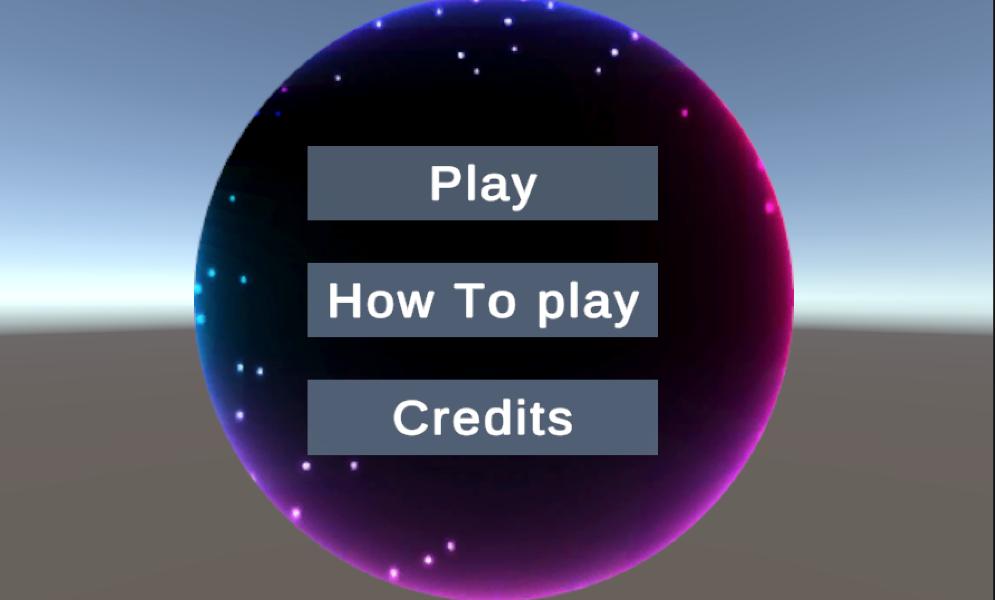

## Assets Needed

### Character

* Principal Character
* Animations

### Terrain/Environment

* Skybox

### Objects

* Prefab #1 Orange cube
* Prefab #2 Yellow cube
* Prefab #3 Green cube
* Prefab #4 Black cube

# Audio

## Style

For this game there is original music, it was composed in a minor key keeping in mind the level design as a guide to match every sound and chord according to the gameplay.

* Gendre: Glitch Hope
* DAW: Ableton Live
* Instruments:
  + Violin 1
  + Violin 2
  + Viola
  + Cello
  + Double bass
  + Synth 1
  + Synth 2
  + Drums

## Music

The song is used with different tempo

* Song #1
  + A New Hero - 90 BPM
* <Song #2>
  + A New Hero - 120 BPM
* <Song #3>
  + A New Hero - 1500 BPM

## Sound Effects

In this version there aren't sound effects, there are the next songs for the scenes:

* Main menu - A New Hero - Verse
* Win Screen - A New Hero - Chorus
* First Level - A New Hero - Complete Song

## Voice Acting

For this version there isn't voices.

# Project Scope

## Time Scale

The schedule is going to be developed in one week.

## Anticipated Gameplay Time

The players must take 15 minutes completing the game

## Cost

Maybe the net time

## Target Platforms

Web

## Team

#### Fabio Betancourt

* Developer
* UI Designer

#### Santiak Domicó

* Level designer
* Sound designer

## Monetization

This game is free and has ads every five times when the player dies.

# Version History

A record of major changes made to this document.

## V1.0 - <Major Changes>

* Unique version